CMSC 204
Huffman Lab
Michael DeReggi

- Create a Huffman Tree and generate the codes for each character of the following input:
create a huffman tree
For consistency:
- If same frequency – put in priority queue alphabetically; put space before other characters of the same frequency
- Add subtrees to end of group with same priority
- Lower number has higher priority (goes to front)

a=1
f=2
h=2
m=1
n=1
r=2
t=2
u=1
c=1
e=4
=1

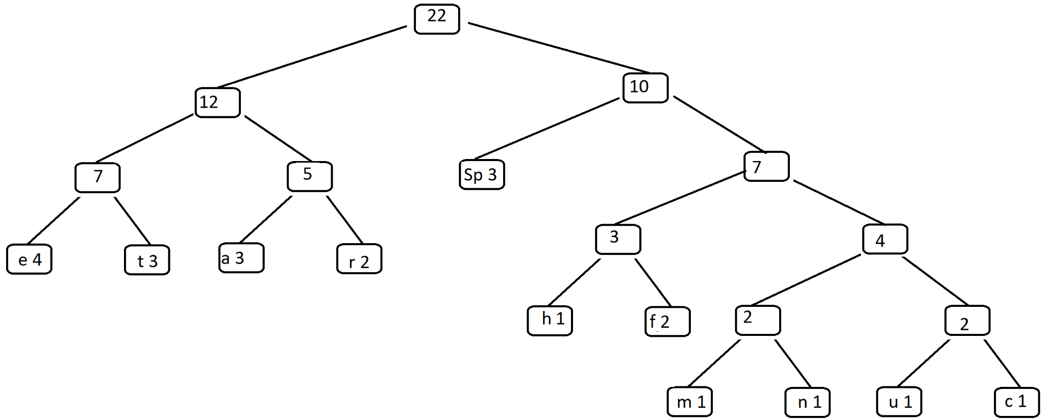

Now encode “create a huffman tree”
11111 011 000 010 001 000 10 010 10 1100 11110 1101 1101 11100 010 11101 10 001 011 000 000

- Based on the following Huffman tree and binary sequence, what is the text

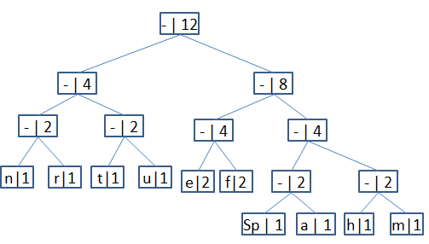

1110 011 101 101 1111 1101 000 1100 010 001 100 100
h u f f m a n Sp t r e e

